1.      What are the disadvantages of Analog communication?  
Its not reliable, Noise effect is more on the signals, Power required for signal transmission also more, Circuit complexity is more and costly.

2.      What are the Advantages of Digital Communication?  
Reliable, Noise effect is very less, power consumption is very less, various Digital ICs are available so circuits not complex , cheap, Error detection and correction is also possible.

3.      What are different types of digital modulation?  
ASK, FSK, PSK, PCM, DPCM,Delta modulation, Adaptive Delta modulation etc..

4.      How to convert an analog signal into digital signal?  
Blocks:  Anti aliasing filter, Sampler, Quantizer, encoder.

5.      Define the functionality of Sampler, Quantizer?  
Sampler: converts a continuous time signal into discrete time signal.  
Quantizer: converts continuous in amplitude signal into discrete in amplitude signal.

6.      What are some Coding techniques?  
Pulse code modulation, Differential pulse code modulation, Delta modulation, Adaptive delta modulation.

7.      What is Sampling?  
Converting a continuous time signal into discrete in time signal is called as Sampling (similar to cutting a bread into slices)

8.      Define Sampling theorem?  
To reconstruct the Continuous time signal from discrete time signal ,the sampling frequency should be more than equal to twice of Continuous time signal frequency(max).

9.      What is Nyquist Rate?  
If the sampling frequency is twice of Continuous time signal frequency(max), then that is called as Nyquist rate.

10.  How many types of samplings are their? Explain briefly?  
Impulse Sampling, Natural sampling, Flat top sampling.

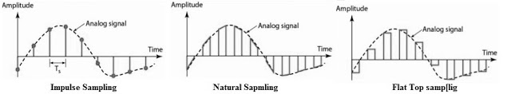

11.  What is aliasing effect?  How to overcome it?  
Due to imperfect sampling the signals will be interfered in frequency domain i.e called aliasing effect in sampling. if sampling theorem satisfied in sampling or first by passing signal from anti aliasing filter before sampling then aliasing effect will be reduced

12.  What are the Analog pulse modulation methods?  
Pulse amplitude modulation, pulse width modulation and pulse position modulation..

13.  Define Pulse amplitude modulation?  
The carrier pulse height (amplitude) proportional to amplitude of messege signal.

14.  Define Pulse width modulation?  
The carrier pulse width proportional to amplitude of message signal.

15.  Define Pulse position modulation?  
The carrier pulse position proportional to amplitude of message signal.

16.  Compare PAM, PWM, PPM?

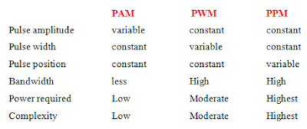

17.  What is Amplitude shift Keying (ASK) ?

It represent the digital data as variations in amplitudes in carrier wave. i.e '1' represented by transmitting a fixed amplitude carrier wave for the bit duration with constant frequency.

18.  What is Phase shift keying ( PSK)?  
It represent the digital data as variations in phase shift in carrier wave. i.e '1' represented by 0 phase shift carrier wave , where '0' represented as 180 phase shift incarrier wave for the bit duration with constant frequency

19.  What is Frequency shift keying (FSK) ?  
It represent the digital data as variation in frequency in carrier wave, i.e for '1' more than carrier frequency , for '0' less than carrier frequency.

20.  What is Binary Phase shift Keying (BPSK) ?  
for each one bit of binary data (0 & 1) carrier phase will be changed (two different shifts: 0, 180)

21.  What is Quadrature Phase shift Keying (QPSK) ?  
for each two bits of binary data (00,01,10 & 11) carrier phase will be changed (four different shifts : 45, 135, -45, -135)

22.  What is the difference between Bit Rate and Baud Rate?  
Bit rate represents Bits per sec,Baud rate represents no. of symbols per second i.e. in communications the no. of bits transmitted per sec is called as Bit Rate (units bps) and The no. of times a signal (here carrier) changes its state (change in freq, phase, amplitude) per sec is called as Baud rate.

23.  What is bandwidth of BPSK signal?  
2Fc, if Fc represents carrier frequency

24.  Compare ASK, PSK and FSK.?  
Bandwidth: ASK< PSK < FSK  
Power:       ASK <PSK = FSK  
Probability of error: ASK > PSK > FSK  
Signal to Noise Ratio: ASK < PSK < FSK

25.  Why is ASK called as ON-OFF keying?

When input data is 1 then output is carrier, if input is 0 out put is zero. so its looks like a switch which will switch on when input is 1 and off when input is zero